**Review Meeting- 037**

Gaurang Garg

BioPhotonica Lab, Centre for Biomedical Engineering, IIT Delhi

2025-09-29 (Monday)

**Title:** Overview of Fourier Ptychography Microscopy

**Abstract:** Fourier Ptychography Microscopy (FPM) is a computational imaging technique to tackle the problems of conventional microscopy by post measurement data processing. It is an iteration based optimization problem that gives high resolution, wide field-of-view and quantitative phase recovery. In this report, I present basic concept and theory of FPM and how it is implemented via algorithms.

# 1. **Introduction**

The intrinsic problem in the conventional microscopy imaging is the trade-off between resolution and field-of-view (FOV) – To extract finer details of the sample, we have to reduce the area of the sample under consideration or we get coarse details with large area of sample covered. This technique takes this problem from domain of hardware and design modifications to the domain of computation to give high resolution output without giving up on FOV and vice versa.

This technique holds tremendous potential in the implementations of quantitative phase imaging. The algorithm used to implement the technique is highly derived from the parent technique called Ptychography which is a phase retrieval technique.

The primary question is the need for this technique as mentioned earlier the conventional optical systems have encountered some problems and cannot be further improved via physical alterations to the setup or the optical components.

## 1.1. **Phase Information**

Light as an electromagnetic wave can be described by a complex amplitude function which has two key pieces of information: amplitude and phase. The amplitude is associated with the energy intensity of the wave and phase represents spatial distribution or the time delay in propagation. The object (sample) represented by a complex object function interacts with the wave and the transmitted wave carries crucial phase information of the object, such as the refractive index and morphology information. Conventional microscopes have photodetectors of some kind which can measure the intensity of the light and consequently lose the crucial phase information of the object.

## 1.2. **Aberration Induced Artifacts**

The objective lens of a microscope acts as a low pass filter with passing frequency determined by the numerical aperture (NA). High spatial frequency corresponds to diffraction at large angles. This limits the resolution of the optical system. To decrease the minimum resolvable distance (increasing the resolution) higher NA objective lens must be used which would give rise to aberration induced artifacts. A better resolution (larger NA) implies a smaller FOV and a shorter depth-of-focus that makes aberration correction harder.

## 1.3. **Resolvable Pixels**

The number of pixels (essentially, the information or the degrees of freedom) that can be recorded are given by the space bandwidth product (SBP). The trade-off between resolution and FOV presents itself physically in this problem as: to increase the number of pixels by detecting more and covering a wide surface in image plane or to reduce the size of one pixel and again increasing the number of pixels in a fixed area. Typical lenses give about 10 megapixels of resolvable pixels. Higher SBP is highly desirable for biomedical applications.

## 1.4. **Label-free Imaging**

Most biological cells are transparent, owing to their poor absorption

# 2. Figures and Tables

Cite all figures and tables with their respective numbers in the body text. Example: "The OCT signal decreases along the depth, as shown in Fig. 5."

Place the figure caption at the bottom of the figure with all details. For figure caption, use the “Caption style”. Write the caption to be self-sufficient for the reader to understand the details about the figures. For example, see below Fig. 1.

If you include any figures in your report that are from a reference, please write the figure caption like this: "Fig. 2(a) is reprinted from Ref. 3," and make sure to cite the reference properly at the end of your report in the references section.

Place the table caption at the top of the table and cite the table number in the text.

# References:

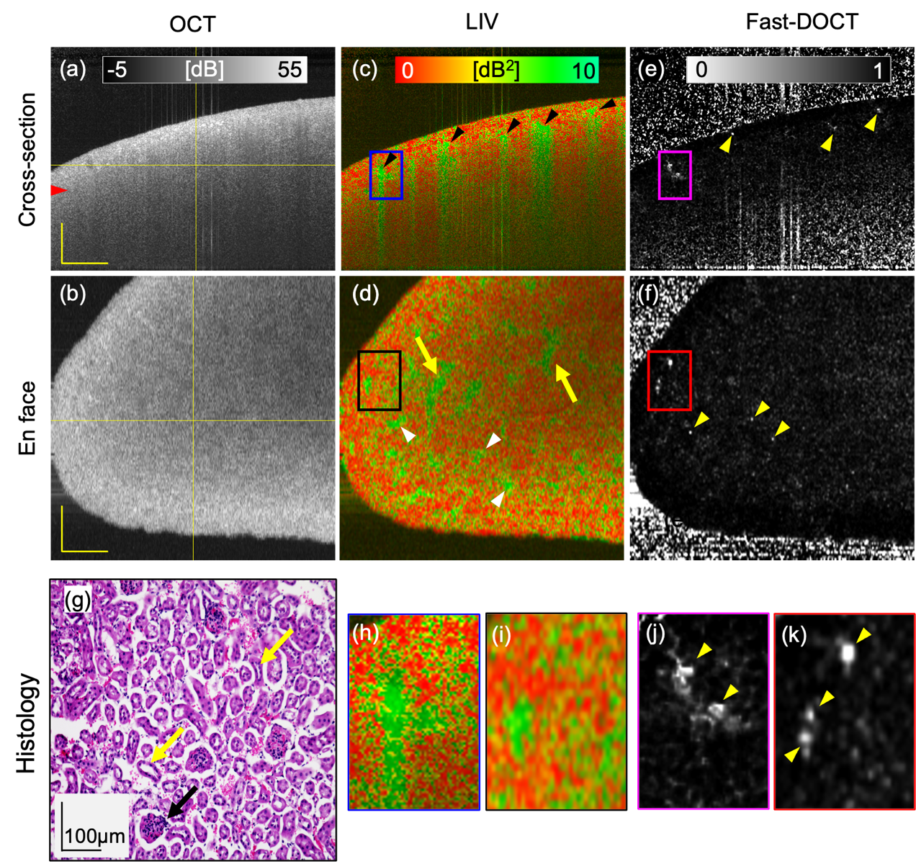

Figure 1: Dynamic OCT imaging of a fresh normal mouse kidney for a 6 mmx 6 mm field of view. Cross-sections from (a) scattering OCT, (c) LIV, and (e) Fast-DOCT imaging; (b, d, f) En face slices of the OCT, LIV, and Fast-DOCT images at the depth location indicated by the horizontal line in (a); (g) H&E stained histological micrograph; (h, j) Magnified images of the LIV and Fast-DOCT cross-section at the region indicated by the rectangular box in (c, e); (i, k) Magnified images of the LIV and Fast-DOCT en face slice at the region indicated by the rectangular box in (d, f). The arrowhead in (a) indicates the depth location of the histology (g). Arrowheads in (c) and (d) indicate the high LIV (green) signals and arrows in (d) represent pipe-like structures. The hyper Fast-DOCT spots in the cross-section and enface are indicated by arrowheads in (e, f, j, k). The black arrow in (g) indicates the glomerulus and the yellow arrows indicate the renal tubules of the kidney tissue. LIV: log-intensity variance; Fast-DOCT: fast dynamic OCT; H&E: Hematoxylin and eosin. Scale bar: 500 µm.

All the claims in the report should be cited with proper references. Use Zotero (Zotero word plugin) to cite references.

See <https://www.zotero.org/support/word_processor_plugin_installation> for details.